**Week – 7: Mandatory Hands-on Exercises**

**Skill:React js**

**Hands on 9:**

**Step 1:** Create cricketapp using command **npx create-react-app cricketapp**

**Step 2: Modify the below code in App.js file**

import React from 'react';

import ListofPlayers from './ListofPlayers';

import IndianPlayers from './IndianPlayers';

function App() {

const flag = true; //change flag as false to Indian players

return (

<div>

<h1>React App</h1>

{flag ? <ListofPlayers /> : <IndianPlayers />}

</div>

);

}

export default App;

**Step 3: Create a file ListofPlayers.js and write the code as below**

import React from 'react';

const players = [

{ name: 'Mr. Jack', score: 50 },

{ name: 'Mr. Michael', score: 70 },

{ name: 'Mr. John', score: 40 },

{ name: 'Mr. Ann', score: 61 },

{ name: 'Mr. Elisabeth', score: 61 },

{ name: 'Mr. Sachin', score: 95 },

{ name: 'Mr. Dhoni', score: 100 },

{ name: 'Mr. Virat', score: 84 },

{ name: 'Mr. Jadeja', score: 64 },

{ name: 'Mr. Raina', score: 75 },

{ name: 'Mr. Rohit', score: 80 }

];

const ListofPlayers = () => {

const below70 = players.filter(player => player.score < 70);

return (

<div>

<h2>List of Players</h2>

<ul>

{players.map((p, index) => (

<li key={index}>{p.name} {p.score}</li>

))}

</ul>

<h2>List of Players having Scores Less than 70</h2>

<ul>

{below70.map((p, index) => (

<li key={index}>{p.name} {p.score}</li>

))}

</ul>

</div>

);

};

export default ListofPlayers;

**Step 4: Create a file IndianPlayers.js and write the below code**

import React from 'react';

const oddTeam = [

{ position: 'First', name: 'Sachin1' },

{ position: 'Third', name: 'Virat3' },

{ position: 'Fifth', name: 'Yuvaraj5' }

];

const evenTeam = [

{ position: 'Second', name: 'Dhoni2' },

{ position: 'Fourth', name: 'Rohit4' },

{ position: 'Sixth', name: 'Raina6' }

];

const T20players = [

'Mr. First Player',

'Mr. Second Player',

'Mr. Third Player'

];

const RanjiTrophyPlayers = [

'Mr. Fourth Player',

'Mr. Fifth Player',

'Mr. Sixth Player'

];

const merged = [...T20players, ...RanjiTrophyPlayers];

const IndianPlayers = () => {

return (

<div>

<h2>Odd Players</h2>

<ul>

{oddTeam.map((player, i) => (

<li key={i}>{player.position} : {player.name}</li>

))}

</ul>

<h2>Even Players</h2>

<ul>

{evenTeam.map((player, i) => (

<li key={i}>{player.position} : {player.name}</li>

))}

</ul>

<h2>List of Indian Players Merged:</h2>

<ul>

{merged.map((player, i) => (

<li key={i}>{player}</li>

))}

</ul>

</div>

);

};

export default IndianPlayers;

**Output: When flag is true:**

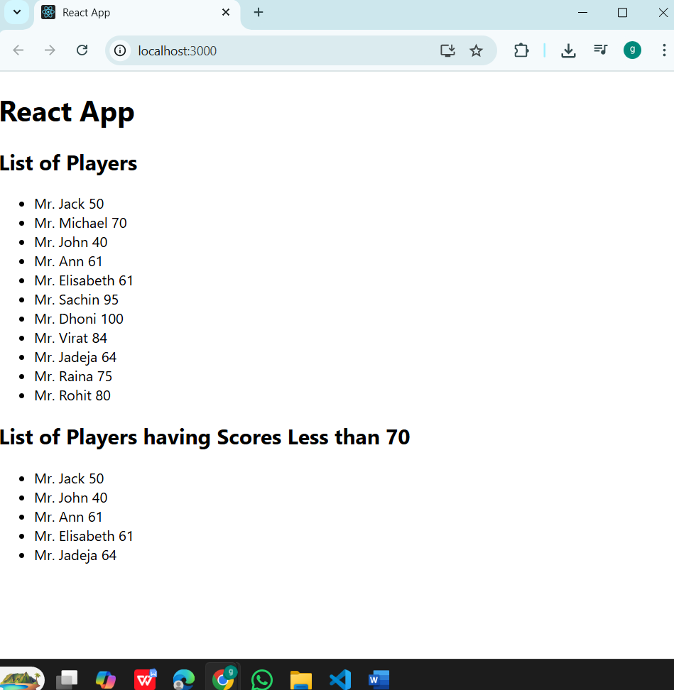

**Output: When flag is false**

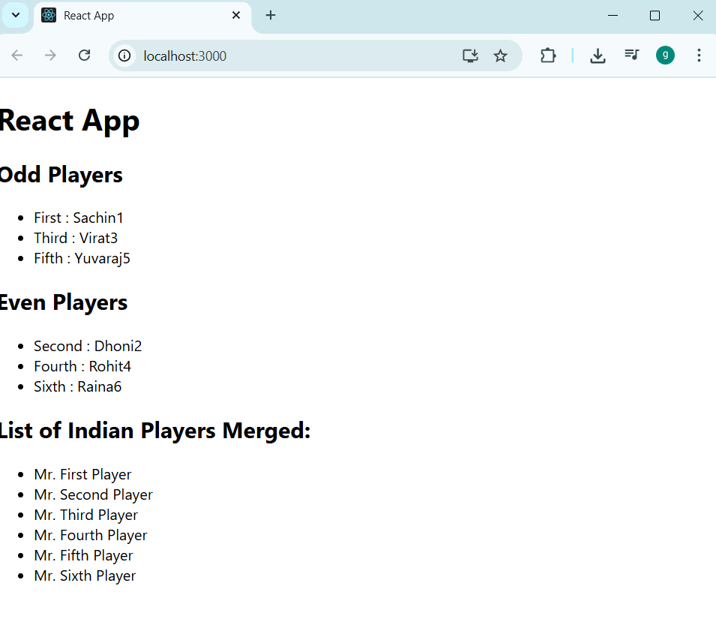

**Hands on – 10:**

**Create a React Application named “officespacerentalapp” which uses React JSX to create elements, attributes and renders DOM to display the page.**

**Create an element to display the heading of the page.**

**Attribute to display the image of the office space**

**Create an object of office to display the details like Name, Rent and Address.**

**Create a list of Object and loop through the office space item to display more data.**

**To apply Css, Display the color of the Rent in Red if it’s below 60000 and in Green if it’s above 60000.**

**Step 1:**create officespacerentalapp using command **npx create-react-app officespacerentalapp**

**Step 2: Modify App.js with below code**

import React from 'react';

function App() {

// Office data object

const office = {

name: 'DBS',

rent: 50000,

address: 'Chennai',

image: 'https://assets.oyoroomscdn.com/cmsMedia/medium/360031bc-ad7f-4519-91b5-85c07170bfcc.jpg'

};

// Dynamic color based on rent value

const rentStyle = {

color: office.rent < 60000 ? 'red' : 'green',

fontWeight: 'bold'

};

return (

<div style={{ textAlign: 'center', marginTop: '40px', fontFamily: 'Arial' }}>

<h1>Office Space , at Affordable Range</h1>

<img

src={office.image}

alt="Office"

style={{ width: '300px', height: '200px', margin: '20px 0' }}

/>

<div style={{ fontSize: '20px' }}>

<p><strong>Name:</strong> {office.name}</p>

<p style={rentStyle}>Rent: Rs. {office.rent}</p>

<p><strong>Address:</strong> {office.address}</p>

</div>

</div>

);

}

export default App;

**Output:**

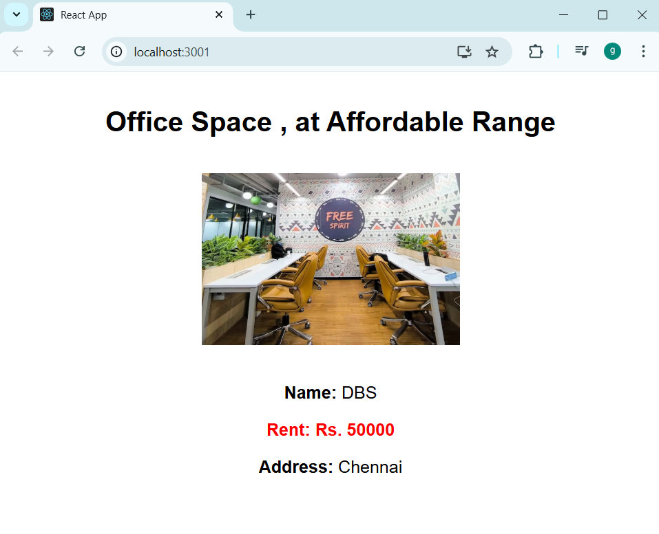

**Hands on 11:**

**Step 1:**Create eventexamplesapp using command **npx create-react-app eventexamplesapp**

**Step 2:Modify App.js with below code**

import React, { Component } from 'react';

import CurrencyConverter from './CurrencyConverter';

class App extends Component {

  constructor(props) {

    super(props);

    this.state = {

      count: 1

    };

  }

  increment = () => {

    this.setState({ count: this.state.count + 1 });

    alert('Hello! Member1');

  };

  decrement = () => {

    this.setState({ count: this.state.count - 1 });

  };

  sayWelcome = (msg) => {

    alert(msg);

  };

  handleClick = (e) => {

    e.preventDefault();

    alert('I was clicked');

  };

  render() {

    return (

      <div style={{ margin: '20px', fontFamily: 'Arial' }}>

        <p>{this.state.count}</p>

        <button onClick={this.increment}>Increment</button> <br /><br />

        <button onClick={this.decrement}>Decrement</button> <br /><br />

        <button onClick={() => this.sayWelcome('welcome')}>Say welcome</button> <br /><br />

        <button onClick={this.handleClick}>Click on me</button> <br /><br />

        <CurrencyConverter />

      </div>

    );

  }

}

export default App;

**Step 3:Create CurrencyConverter.js and write the code as below**

import React, { Component } from 'react';

class CurrencyConverter extends Component {

  constructor(props) {

    super(props);

    this.state = {

      amount: ''

    };

  }

  handleChange = (e) => {

    this.setState({ amount: e.target.value });

  };

  handleSubmit = (e) => {

    e.preventDefault();

    const euroRate = 80;

    const result = parseFloat(this.state.amount) * euroRate;

    if (!isNaN(result)) {

      alert(`Converting to Euro Amount is ${result}`);

    } else {

      alert('Please enter a valid number.');

    }

  };

  render() {

    return (

      <div style={{ marginTop: '30px' }}>

        <h2 style={{ color: 'green' }}>Currency Convertor!!!</h2>

        <form onSubmit={this.handleSubmit}>

          <label>

            Amount: <input type="number" value={this.state.amount} onChange={this.handleChange} />

          </label>

          <br /><br />

          <label>

            Currency: <input type="text" value="Euro" readOnly />

          </label>

          <br /><br />

          <button type="submit">Submit</button>

        </form>

      </div>

    );

  }

}

export default CurrencyConverter;

**Output:**

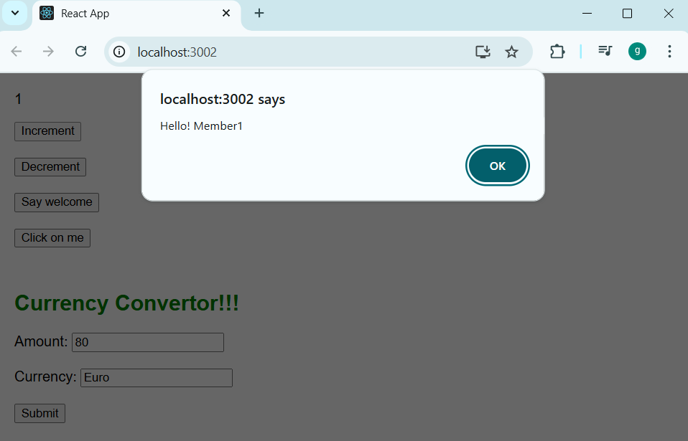

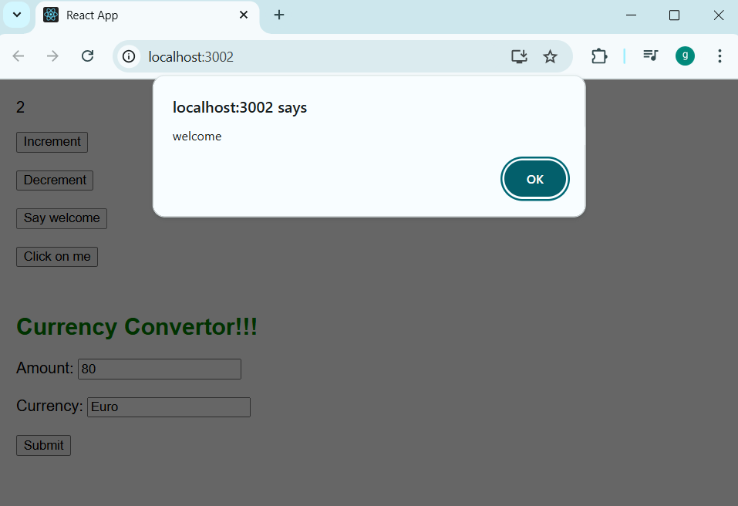

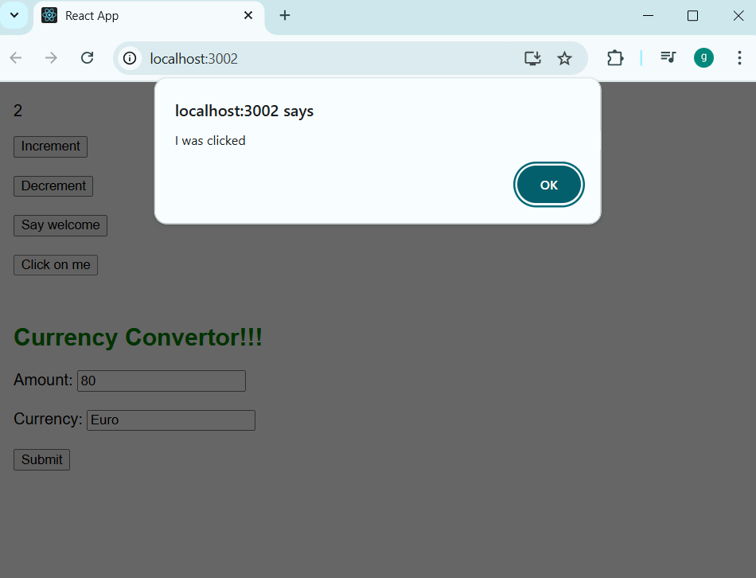

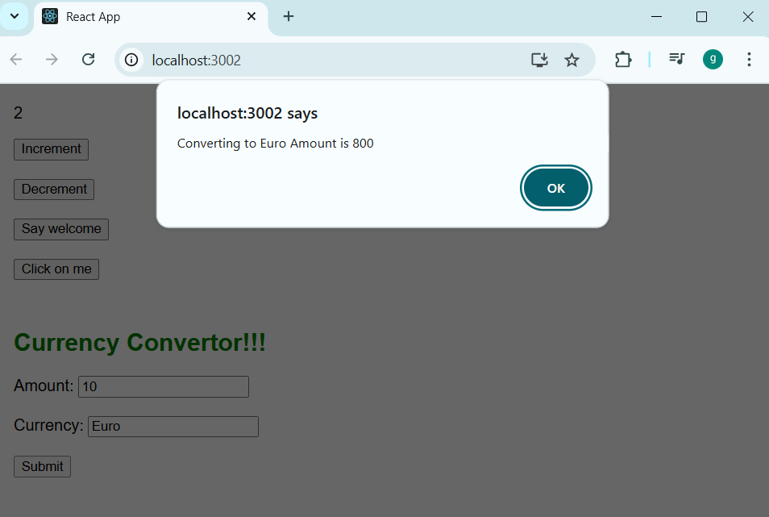

**Hands on 12:**

**Create a React Application named “ticketbookingapp” where the guest user can browse the page where the flight details are displayed whereas the logged in user only can book tickets.**

**The Login and Logout buttons should accordingly display different pages. Once the user is logged in the User page should be displayed. When the user clicks on Logout, the Guest page should be displayed.**

**Step 1:** Create ticketbookingapp with command **npx create-react-app ticketbookingapp**

**Step 2:Modify the code in App.js with below code**

import React, { Component } from 'react';

import GuestPage from './GuestPage';

import UserPage from './UserPage';

class App extends Component {

constructor(props) {

super(props);

this.state = {

isLoggedIn: false

};

}

handleLogin = () => {

this.setState({ isLoggedIn: true });

};

handleLogout = () => {

this.setState({ isLoggedIn: false });

};

render() {

const { isLoggedIn } = this.state;

let page;

if (isLoggedIn) {

page = <UserPage onLogout={this.handleLogout} />;

} else {

page = <GuestPage onLogin={this.handleLogin} />;

}

return (

<div style={{ fontFamily: 'Arial', padding: '20px' }}>

<h1>✈️ Welcome to Ticket Booking App</h1>

{page}

</div>

);

}

}

export default App;

**Step 3: create a file GuestPage.js and write below code**

import React from 'react';

const GuestPage = ({ onLogin }) => {

return (

<div>

<h2>Flight Details</h2>

<ul>

<li>Flight: AI203 | From: Delhi | To: Mumbai | Time: 10:30 AM</li>

<li>Flight: AI101 | From: Mumbai | To: Bangalore | Time: 2:00 PM</li>

<li>Flight: AI509 | From: Chennai | To: Hyderabad | Time: 5:45 PM</li>

</ul>

<button onClick={onLogin}>Login to Book Tickets</button>

</div>

);

};

export default GuestPage;

S**tep 4:create a file UserPage.js and write the below code**

import React from 'react';

const UserPage = ({ onLogout }) => {

return (

<div>

<h2>Welcome, User!</h2>

<p>You can now book your flight tickets.</p>

<ul>

<li>Flight: AI203 - ₹5,000 <button>Book</button></li>

<li>Flight: AI101 - ₹4,500 <button>Book</button></li>

<li>Flight: AI509 - ₹6,000 <button>Book</button></li>

</ul>

<button onClick={onLogout}>Logout</button>

</div>

);

};

export default UserPage;

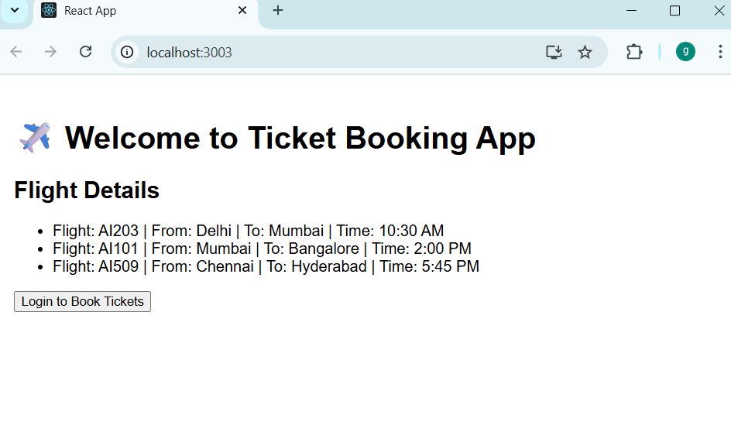**Output:**

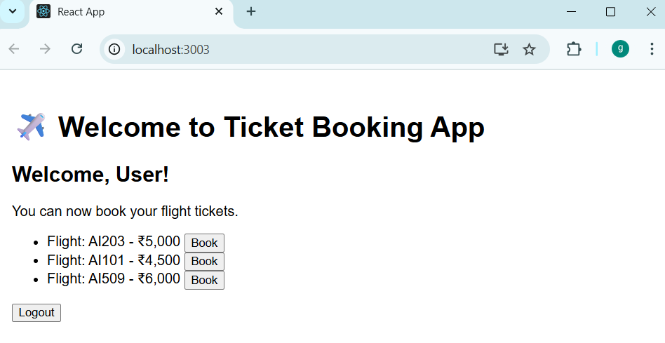

**Additional important hands on exercises:**

**Hands on 13:**

**Step 1:**Create bloggerapp using command **npx create-react-app bloggerapp**

**Step 2:Modify app.js with below code**

// src/App.js

import React from 'react';

import './App.css'; // Import your CSS file

import CourseDetails from './CourseDetails';

import BookDetails from './BookDetails';

import BlogDetails from './BlogDetails';

import { courses, books, blogs } from './data'; // Import your data

function App() {

return (

<div className="App">

<div className="header">

<h1>React App</h1>

</div>

<div className="content-container">

<CourseDetails courses={courses} />

<div className="separator"></div>

<BookDetails books={books} />

<div className="separator"></div>

<BlogDetails blogs={blogs} />

</div>

</div>

);

}

export default App;

**Step 2:style App.css with below code**

/* src/App.css */

.App {

font-family: Arial, sans-serif;

text-align: center;

margin-top: 20px;

}

.header {

margin-bottom: 30px;

}

.content-container {

display: flex;

justify-content: center;

gap: 20px; /* Space between sections */

}

.details-section {

flex: 1; /* Allows sections to take equal width */

padding: 0 20px;

text-align: left; /* Align text within sections to the left */

}

.details-section h2 {

font-size: 24px;

margin-bottom: 20px;

color: #333;

}

.details-section h3 {

font-size: 18px;

margin-bottom: 5px;

color: #555;

}

.details-section p {

font-size: 16px;

margin-top: 0;

color: #777;

}

.separator {

width: 2px;

background-color: green;

}

/* Specific styling for the last separator if needed, or adjust gap */

.content-container .details-section:last-child + .separator {

display: none; /* Hide the separator after the last column */

}

**Step 3: create blogdetails.js and write the below code**

// src/BlogDetails.js

import React from 'react';

const BlogDetails = ({ blogs }) => {

return (

<div className="details-section">

<h2>Blog Details</h2>

{blogs.map(blog => (

<div key={blog.id}>

<h3>{blog.title}</h3>

<p>{blog.author}</p>

<p>{blog.content}</p>

</div>

))}

</div>

);

};

export default BlogDetails;

**Step 4: create BookDetails.js and write below code**

// src/BookDetails.js

import React from 'react';

const BookDetails = ({ books }) => {

return (

<div className="details-section">

<h2>Book Details</h2>

{books.map(book => (

<div key={book.id}>

<h3>{book.name}</h3>

<p>{book.price}</p>

</div>

))}

</div>

);

};

export default BookDetails;

**Step 5:create CourseDetails.js and write below code**

// src/CourseDetails.js

import React from 'react';

const CourseDetails = ({ courses }) => {

return (

<div className="details-section">

<h2>Course Details</h2>

{courses.map(course => (

<div key={course.id}>

<h3>{course.name}</h3>

<p>{course.date}</p>

</div>

))}

</div>

);

};

export default CourseDetails;

**Step 6: create data,js file**

// src/data.js

export const courses = [

{ id: 1, name: 'Angular', date: '4/5/2021' },

{ id: 2, name: 'React', date: '6/3/2020' },

];

export const books = [

{ id: 1, name: 'Master React', price: '670' },

{ id: 2, name: 'Deep Dive Into Angular 11', price: '800' },

{ id: 3, name: 'Mongo Essentials', price: '450' },

];

export const blogs = [

{ id: 1, title: 'React Learning', author: 'Stephen Biz', content: 'Welcome to learning React!' },

{ id: 2, title: 'Installation', author: 'Schewzdenier', content: 'You can install React from npm.' },

];

**Output:**

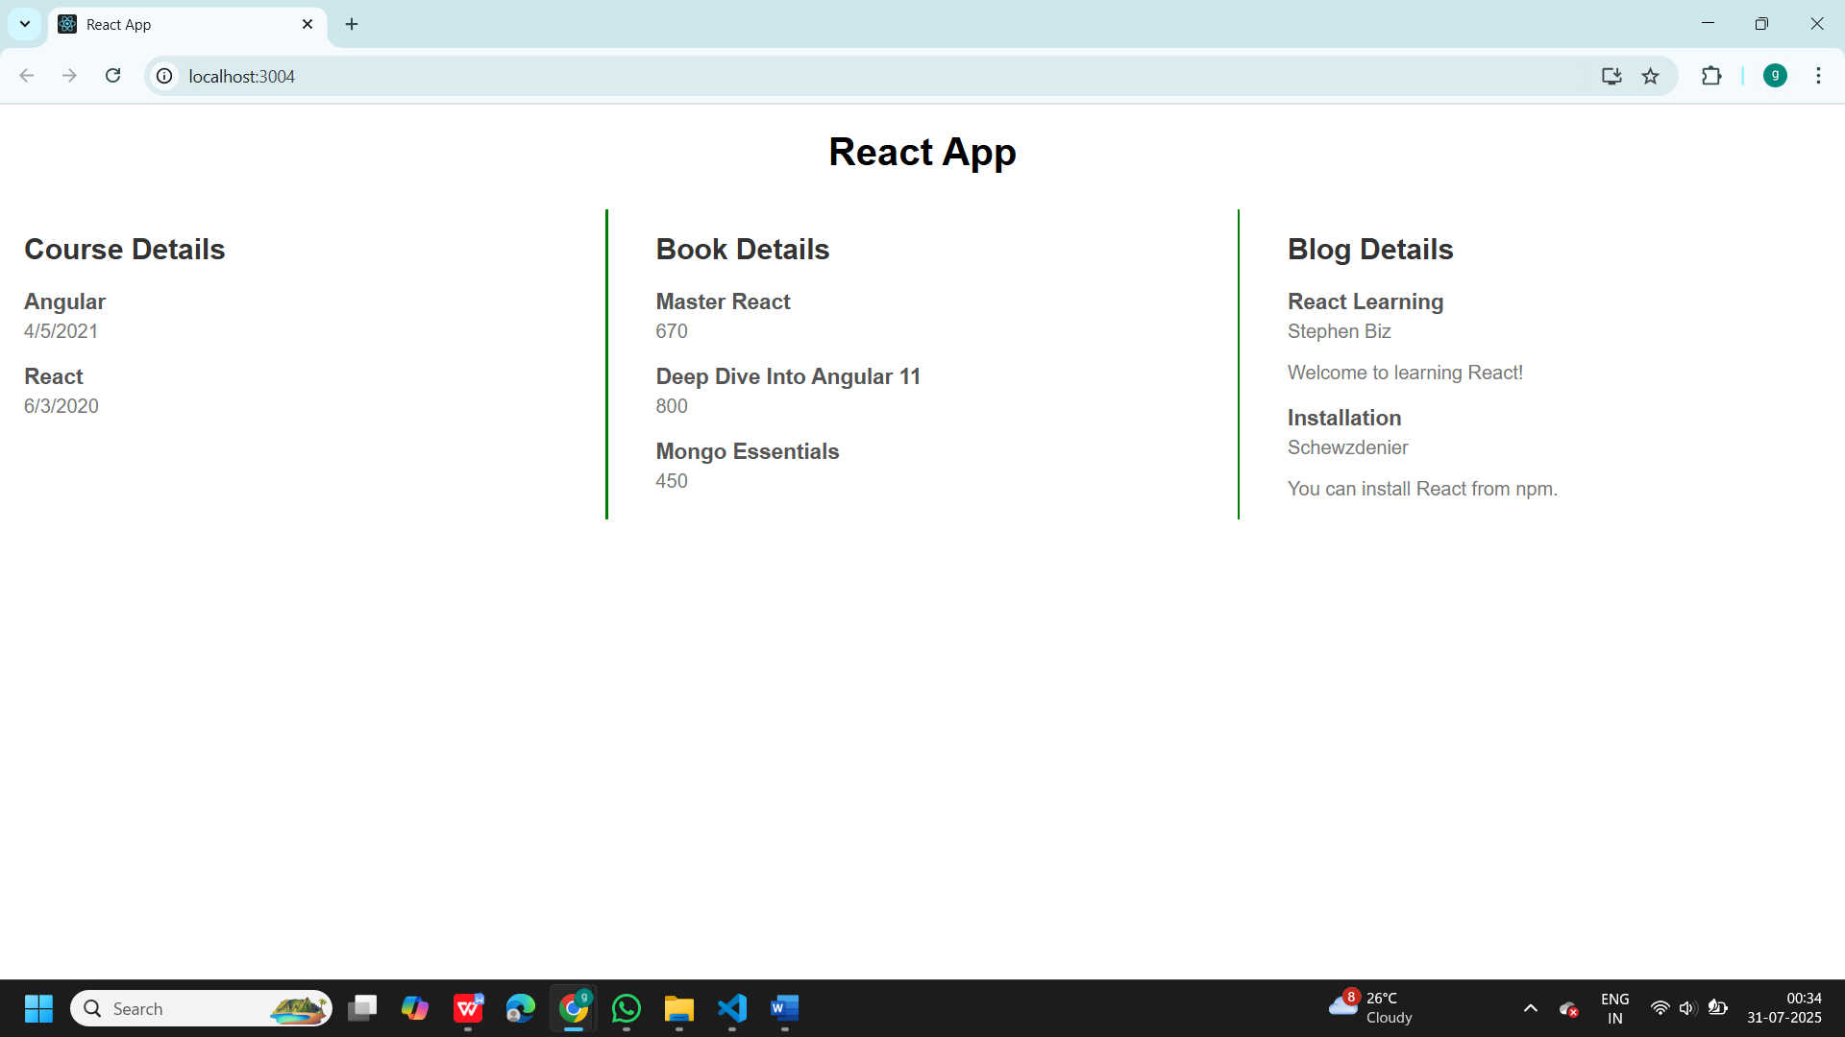

**Hands on 14:**

**Step 1**: Create Employeesapp using command **npx create-react-app Employeesapp**

**Step 2:Create ThemeContext.js file and write the below code**

// ThemeContext.js

import React from 'react';

const ThemeContext = React.createContext('light'); // default value

export default ThemeContext;

**Step 3: Modify App.js file with below code**

// App.js

import React, { useState } from 'react';

import EmployeesList from './EmployeesList';

import ThemeContext from './ThemeContext';

function App() {

const [theme, setTheme] = useState('light');

return (

<ThemeContext.Provider value={theme}>

<div className="App">

<h1>Employee Management App</h1>

<EmployeesList />

</div>

</ThemeContext.Provider>

);

}

export default App;

**Step 4:Create EmployeesList.js and write the below code**

// EmployeesList.js

import React from 'react';

import EmployeeCard from './EmployeeCard';

const employees = [

{ id: 1, name: 'John Doe', position: 'Developer' },

{ id: 2, name: 'Jane Smith', position: 'Designer' }

];

function EmployeesList() {

return (

<div>

{employees.map(emp => (

<EmployeeCard key={emp.id} employee={emp} />

))}

</div>

);

}

export default EmployeesList;

**Step 5:Create EmployeeCard.js file and write the below code**

// EmployeeCard.js

import React, { useContext } from 'react';

import ThemeContext from './ThemeContext';

function EmployeeCard({ employee }) {

const theme = useContext(ThemeContext);

return (

<div className={`card ${theme}`}>

<h2>{employee.name}</h2>

<p>{employee.position}</p>

<button className={theme}>Click Me</button>

</div>

);

}

export default EmployeeCard;

**Output:**

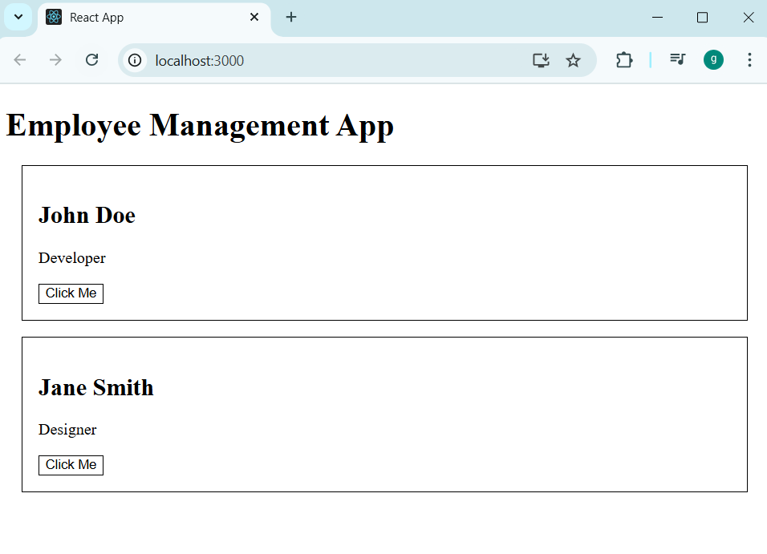

**Hans on 15:**

**Step 1**:Create ticketraisingapp using command **npx create-react-app ticketraisingapp**

**Step 2:Create a ComplaintRegister.js file and write below code**

// ComplaintRegister.js

import React, { useState } from 'react';

function ComplaintRegister() {

const [employeeName, setEmployeeName] = useState('');

const [complaint, setComplaint] = useState('');

const handleSubmit = (e) => {

e.preventDefault();

if (employeeName.trim() === '' || complaint.trim() === '') {

alert('Please fill in all fields');

return;

}

const referenceNumber = 'REF' + Math.floor(1000 + Math.random() * 9000);

alert(`Complaint registered successfully!\nReference Number: ${referenceNumber}`);

setEmployeeName('');

setComplaint('');

};

return (

<div style={{ padding: '2rem' }}>

<h2>Complaint Registration Form</h2>

<form onSubmit={handleSubmit}>

<div style={{ marginBottom: '1rem' }}>

<label>Employee Name:</label><br />

<input

type="text"

value={employeeName}

onChange={(e) => setEmployeeName(e.target.value)}

required

/>

</div>

<div style={{ marginBottom: '1rem' }}>

<label>Complaint:</label><br />

<textarea

rows="5"

value={complaint}

onChange={(e) => setComplaint(e.target.value)}

required

/>

</div>

<button type="submit">Register Complaint</button>

</form>

</div>

);

}

export default ComplaintRegister;

**Step 3:Modify app.js file**

// App.js

import React from 'react';

import ComplaintRegister from './ComplaintRegister';

function App() {

return (

<div className="App">

<ComplaintRegister />

</div>

);

}

export default App;

**Output:**

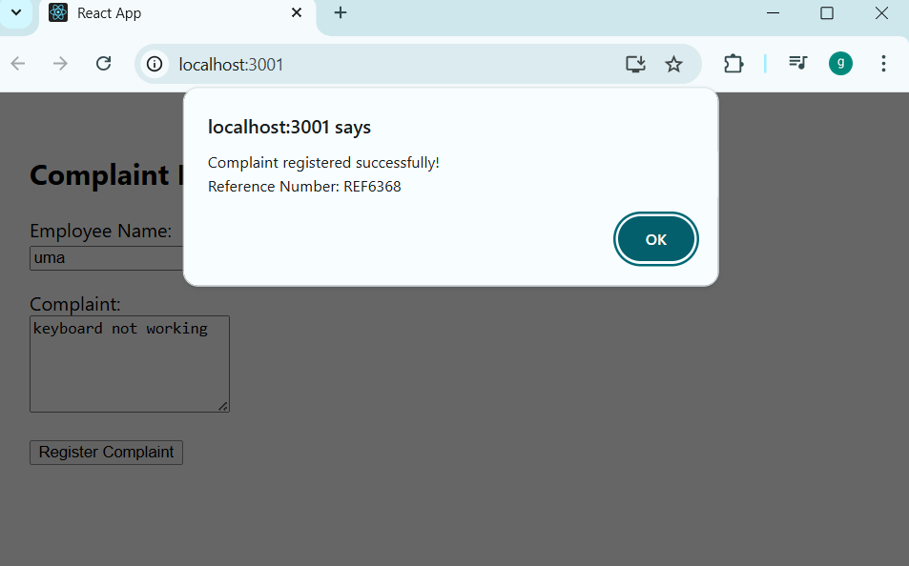

**Hands on 16:**

**Step 1:**Create mailregisterapp using command **npx create-react-app mailregisterapp**

**Step 2:Create Register.js file and write the below code**

// Register.js

import React, { useState } from 'react';

function Register() {

const [formData, setFormData] = useState({

name: '',

email: '',

password: ''

});

const [errors, setErrors] = useState({});

const handleChange = (e) => {

setFormData({ ...formData, [e.target.name]: e.target.value });

};

const validate = () => {

let tempErrors = {};

let isValid = true;

if (formData.name.length < 5) {

tempErrors.name = "Name should have at least 5 characters.";

isValid = false;

}

if (!formData.email.includes('@') || !formData.email.includes('.')) {

tempErrors.email = "Email should contain @ and .";

isValid = false;

}

if (formData.password.length < 8) {

tempErrors.password = "Password should have at least 8 characters.";

isValid = false;

}

setErrors(tempErrors);

return isValid;

};

const handleSubmit = (e) => {

e.preventDefault();

if (validate()) {

alert('Form submitted successfully!');

setFormData({ name: '', email: '', password: '' });

setErrors({});

}

};

return (

<div style={{ width: '300px', margin: '2rem auto' }}>

<h2>Register Form</h2>

<form onSubmit={handleSubmit}>

<div>

<label>Name:</label><br />

<input

type="text"

name="name"

value={formData.name}

onChange={handleChange}

/>

<div style={{ color: 'red' }}>{errors.name}</div>

</div>

<div>

<label>Email:</label><br />

<input

type="text"

name="email"

value={formData.email}

onChange={handleChange}

/>

<div style={{ color: 'red' }}>{errors.email}</div>

</div>

<div>

<label>Password:</label><br />

<input

type="password"

name="password"

value={formData.password}

onChange={handleChange}

/>

<div style={{ color: 'red' }}>{errors.password}</div>

</div>

<button type="submit" style={{ marginTop: '1rem' }}>Register</button>

</form>

</div>

);

}

export default Register;

**Step 3:Modify App.js file with below code**

// App.js

import React from 'react';

import Register from './Register';

function App() {

return (

<div className="App">

<Register />

</div>

);

}

export default App;

**Output:**

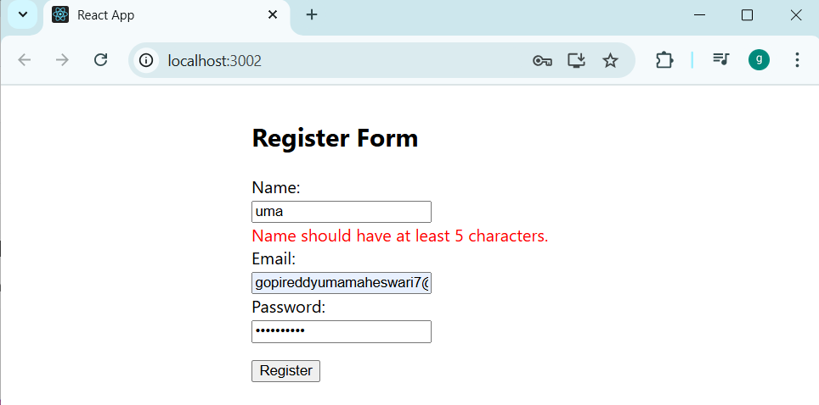

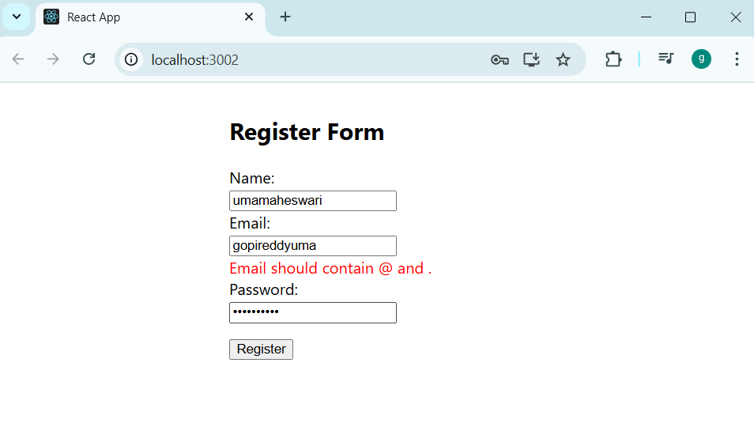

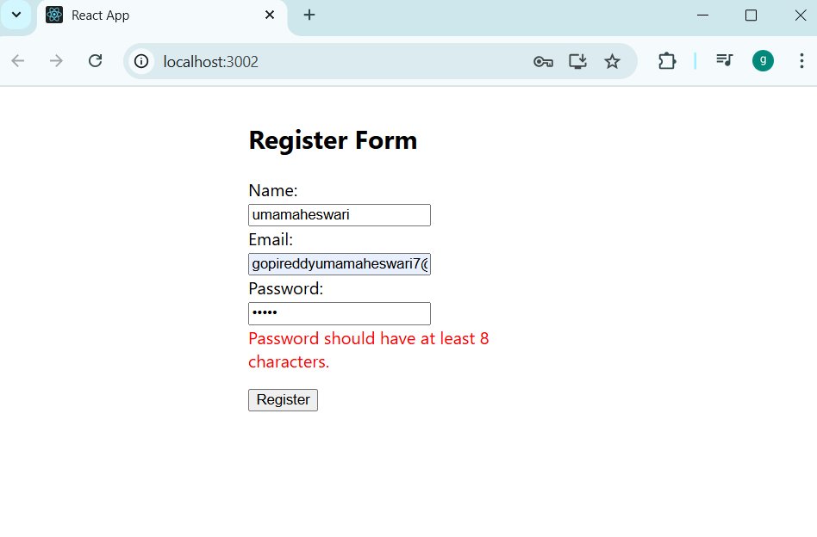

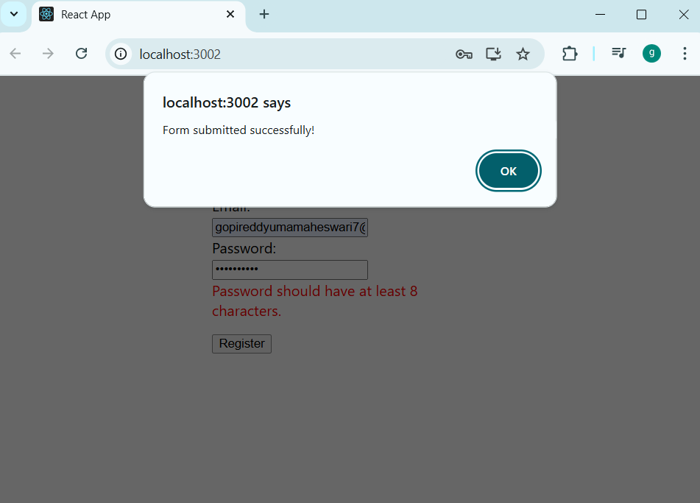

**Hands on 17:**

**Step 1:**Create fetchuserapp using command **npx create-react-app fetchuserapp**

**Step 2:Create Getuser.js file and write below code**

// Getuser.js

import React from 'react';

class Getuser extends React.Component {

constructor() {

super();

this.state = {

user: null

};

}

async componentDidMount() {

try {

const response = await fetch('https://api.randomuser.me/');

const data = await response.json();

this.setState({ user: data.results[0] });

} catch (error) {

console.error("Error fetching user:", error);

}

}

render() {

const { user } = this.state;

return (

<div style={{ padding: '2rem' }}>

<h2>User Details</h2>

{user ? (

<div>

<p><strong>Title:</strong> {user.name.title}</p>

<p><strong>First Name:</strong> {user.name.first}</p>

<img src={user.picture.large} alt="User" />

</div>

) : (

<p>Loading user data...</p>

)}

</div>

);

}

}

export default Getuser;

**Step 3:Modify the App.js file**

// App.js

import React from 'react';

import Getuser from './Getuser';

function App() {

return (

<div className="App">

<Getuser />

</div>

);

}

export default App;

**Output:**

